**DATA SCIENCE REPORT**

False accusations on black crime

**CTEC 128**

**Professor jackson**

**13 March 2023**

**Amrani wooden**

**Loren anderson**

**Lucky uchendu**

**Aaronea wiggins**

**Tyler thomas**

**Introduction**

The perception that black crime is the leading crime in America is a misconception that arises from several factors, including media representation, societal biases, and systemic inequalities. However, a closer examination of crime statistics reveals a more nuanced picture. Some various factors and intangibles lead to bias and false accusations for inconsistent numbers and corrupt data. For example, Media Representation is one of the most popular intangibles because this sensationalizes crimes involving black individuals, leading to a disproportionate focus on these incidents. This can create the perception that black crime is more prevalent than it is and makes crimes committed by white individuals receive less attention, contributing to a skewed perception of crime. Throughout time african Americans have always been the center of attention facing wrong stereotypes and accusations of being the most violent and less civilized and have forced those images over to media and control narratives on how we are perceived and viewed. Another example is Systemic Inequalities and this plays a significant role in crime rates because various communities that face poverty, lack of access to education and employment opportunities, and systemic discrimination are more likely to experience higher crime rates. These factors disproportionately affect black communities due to historical injustices and ongoing systemic racism and marginalizing one particular race within specific communities is an easy way to target a group with low resources and high desperation for any unlaw actions. The system has certain bias programs where there is not much benefit and assistance to underdeveloped communities making it easy to paint and show an image that people are violent and have no self-control.

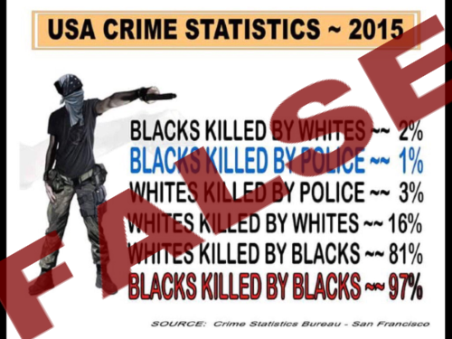

**Data ingestion**

Within the very few first steps, we have collected data from the National US Bureau and there have been Arrests, by Race and Ethnicity, in 2019. In 2019, 69.4 percent of all individuals arrested were White, 26.6 percent were Black or African American, and 4.0 percent were of other races.Of arrestees for whom ethnicity was reported, 19.1 percent were Hispanic or Latino. Of all juveniles (persons under the age of 18) arrested in 2019, 62.5 percent were White, 33.9 percent were Black or African American, and 3.6 percent were of other races. Of juvenile arrestees for whom ethnicity was reported, 23.6 percent were Hispanic or Latino. Of all adults arrested in 2019, 69.9 percent were White, 26.1 percent were Black or African American, and 4.0 percent were of other races. Of adult arrestees for whom ethnicity was reported, 18.8 percent were Hispanic or Latino. White individuals were arrested more often for violent crimes than individuals of any other race and accounted for 59.1 percent of those arrests. Some states consistently rank among the highest in terms of reported crime rates, although these rankings can vary depending on the specific type of crime being measured and our group has crunched data that the most popular states with these specific demographics take places in the most leading crimes and are followed by California, Texas, Florida, and Illinois often making them among the top states for overall reported crime rates.

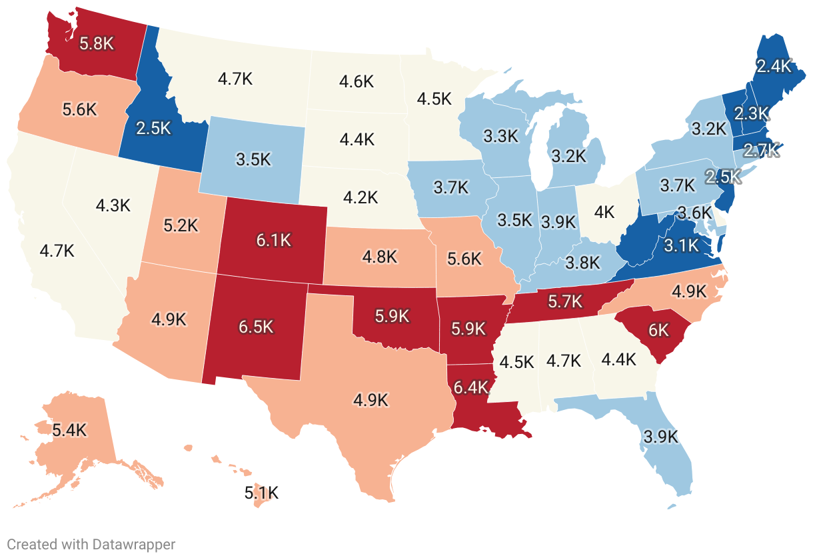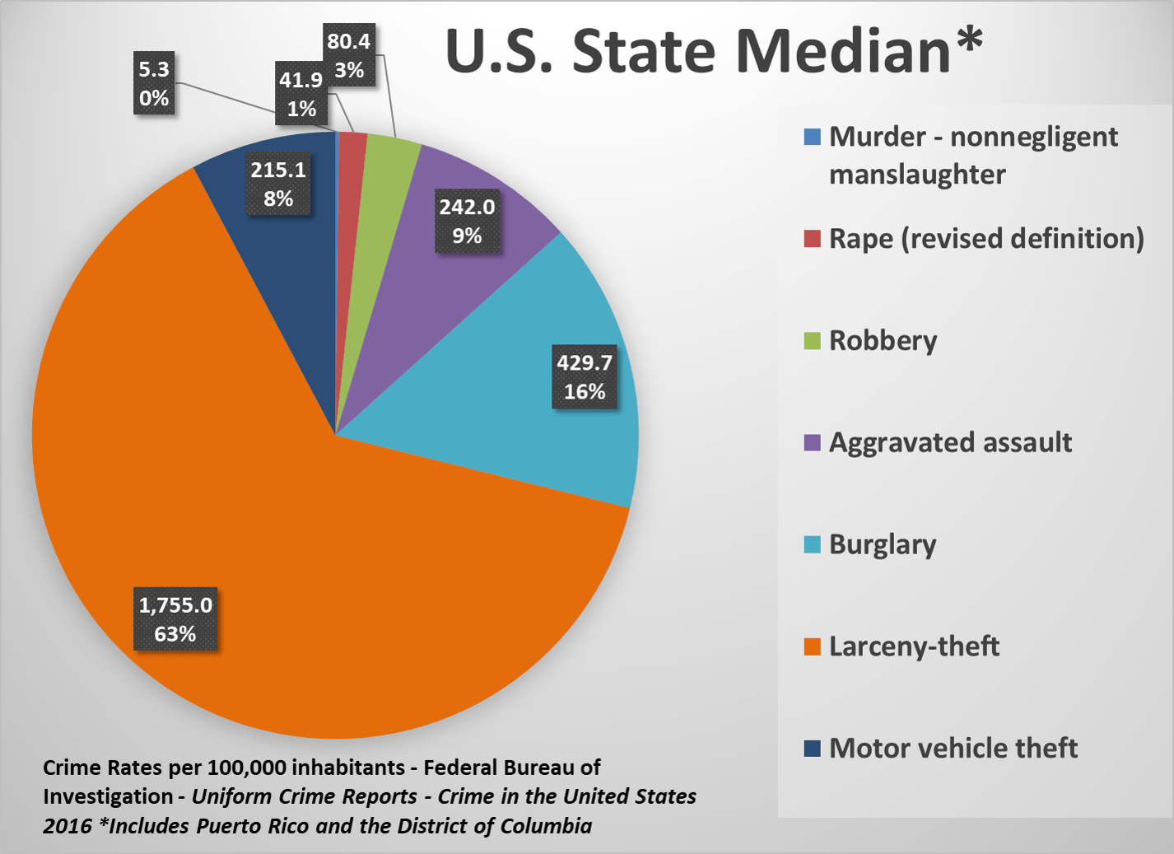

**Data wrangling**

For each data set collected and thoroughly analyzed, we have also resulted in demographic juveniles and which percentages stood out for what race and where were the leading factors for all data sets. For adults arrested for murder, 51.3 percent were Black or African American, 45.7 percent were White, and 3.0 percent were of other races. White juveniles comprised 50.3 percent of all juveniles arrested for violent crimes, and Black or African American juveniles accounted for 46.4 percent of juveniles arrested for violent crimes. White juveniles comprised 54.9 percent of all juveniles arrested for property crimes. Of juveniles arrested for drug abuse violations, 74.8 percent were White. White juveniles comprised 56.4 percent of juveniles arrested for aggravated assault and 55.4 percent of juveniles arrested for larceny theft. Crime statistics in the United States are typically compiled and It provides valuable information on crime rates, types of offenses, and demographic characteristics of both victims and perpetrators.

**Exploratory Data Analysis**

After data collection and examination of the stereotype, it is mainly dependent upon where a Black American lives for criminal accusations. The patterns and trends found within the research shows it is dependent on the specific crime where the Black American will override White people– percentage wise. Robbery at 52.7% and Murder at 51.2% are the two categories that Black Americans are higher. From observation, it is believed these two crimes are connected to money. Reason being, 33% of Blacks are earning at least $75,000 annually. With the economy today, last year, a decade prior, and decades before– survival mode has been instilled in blacks because of Money and a lack thereof.

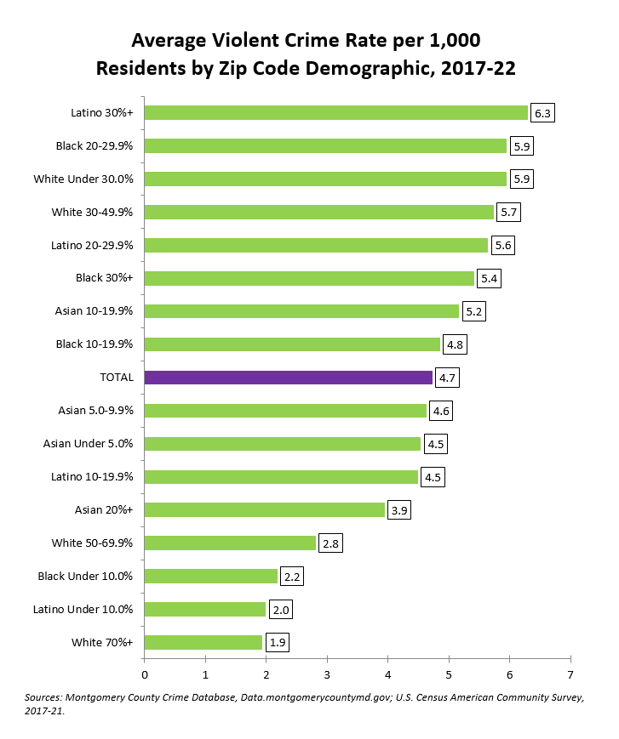

**Data Insights**

From the research conducted, it has been learned that the stereotype–False Accusations on Black crime, has been proven to be, invalid. According to the Crime Stats using the FBI Database, It has been declared that Caucasian Americans are reported as the highest Ethnicity and Race to commit crimes. While researching this topic, the approach needed to be with sensitivity acknowledging that stereotypes can perpetuate harmful biases. Based on the analysis, realistic steps that can be taken to address the problems projected within the objective is to, commit to a systemic change for better representation of Black Americans. Plan community engagements to show that there is peace and love versus hatred and harm within the community Lastly, leadership– a simple vote could start a change of viewpoints on Blacks.

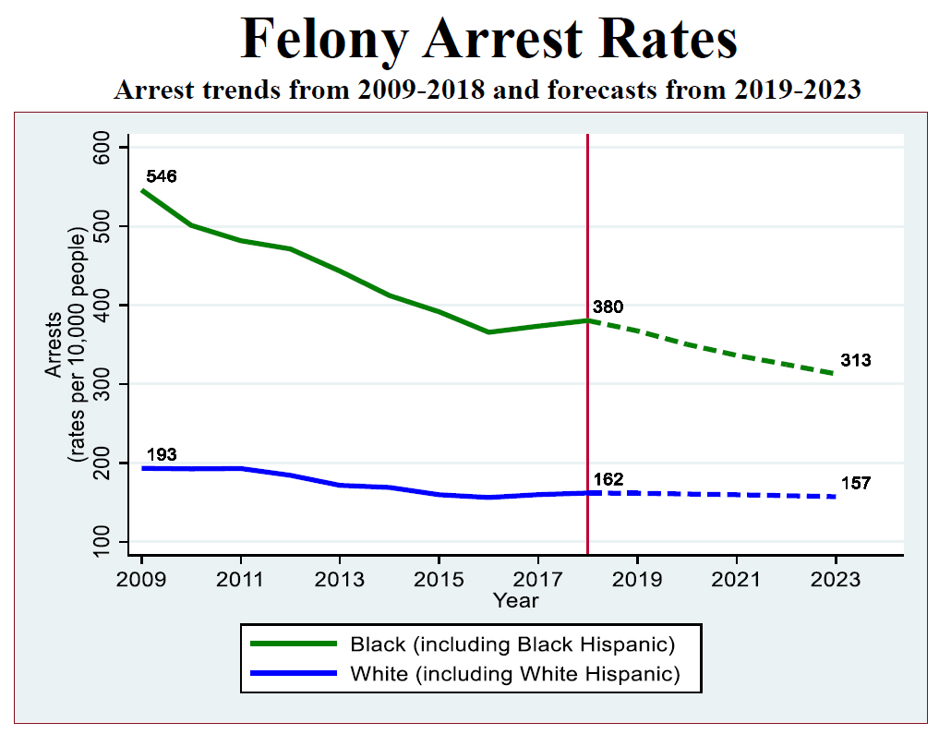

**Recommendations**

To correct the falsely accused Black Americans for/of crimes and as stated previously, it is recommended there is a collaborative and comprehensive effort for resolution. Since the media is our mainstream of information, it would be the primary source to report the correct information and avoid projecting stereotypes. For example, if a crime occurs in Southeast, D.C., reports are quick to identify 1. The Race 2. The neighbor”hood”, 3. The very detail-oriented report of the occurrence 4. A reward, 5. The status of the criminal –dead or alive… in jail. Versus if the criminal incident occurred in the neighborhood of the true highest statistical race or Predominantly white area, media would not release nearly as much information. Also, it is recommended to create safe spaces. Coming in at number two on the FBI Crime Stats site, Black Americans are not perfect. However, there are not many open doors to have the talks that are necessary to prevent a crime. Poverty is a great issue amongst blacks. Blacks are behind in the race and overlooked causing stressful and depressing environments. Safe spaces to educate and confide in one another, are a must to become better individuals first, and a better community last.

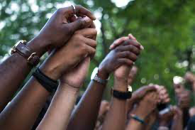

References

<https://ojjdp.ojp.gov/statistical-briefing-book/crime/faqs/ucr_table_2>

<https://ucr.fbi.gov/crime-in-the-u.s/2019/crime-in-the-u.s.-2019/topic-pages/tables/table-43>

<https://www.statista.com/statistics/183489/population-of-the-us-by-ethnicity-since-2000/>

<https://www.statista.com/statistics/183489/population-of-the-us-by-ethnicity-since-2000/>